 

Car picker

# Prepared by:

|  |  |  |
| --- | --- | --- |
| **#** | **Name** | **Track** |
| **1** | Ahmed Shaban Ahmed (Team Leader) | Professional Web Development & BI |
| **2** | Alaa Zayan Saad |
| **3** | Esraa AbdelKawy AbdelSalam |
| **4** | Esraa Mostafa Ahmed |
| **5** | Rabab Mohamed Helmy |
| **6** | Salma Hassan Ramadan |  |
| **7** | Muhammad Alaaeddin Eid |  |

**Project Supervisor:**

Eng. Ghada Kadous

Intake 41 27/06/2021

|  |  |
| --- | --- |
| **Table of Contents** | **2** |
| 0. **Acknowledgment** | 3 |
| 1. **Introduction** | **4** |
| 1.1 Background | 5 |
| 1.2 Purpose | 5 |
| 1.3 Competitors Analysis | 6 |
| 1.4 Customers Analysis | 6 |
| 1.5 Scope of Work | 6 |
| 1.6 Business Model | 6 |
| 2. **Requirements** | **7** |
| 2.1 Functional Requirements | 7 |
| 2.1.1 List of features or functional requirements | 7 |
| 2.2 Use Cases | 8 |
| 2.2.1 Actors | 8 |
| 2.2.2 List of use cases | 8 |
| 2.2.3 Use case diagrams | 9 |
| 2.3 Classes | 12 |
| 2.3.1 List of classes | 12 |
| 2.4 Non-Functional Requirements | 15 |
| 2.4.1 Performance Requirements | 15 |
| 3. **Objectives (List of Services)** | **16** |
| 4. **Design Overview** | **17** |
| 4.1 System Architecture | 17 |
| 4.2 Data Design (Entity Relationship Diagram)  4.3 SWOT analysis | 18  23 |
| 5. **Implementation** | **19** |
| 5.1 Tools and Technologies | 19 |
| 5.2 Hardware Requirements | 19 |
|  |  |

|  |  |
| --- | --- |
|  |  |
|  |  |
|  |  |
| 6. **Future Work** |  |
| 7. **User Guide** | **22** |
| 7.1 User Cycle | 22 |
|  | 39 |

**Acknowledgment**

Thanks for ITI’s staff for the great effort, we are grateful for having such experience with every single person, for having supportive instructors, inspirational environment and without your helpfulness and directness, the ITI internship would have been more challenging. Thanks to our instructors for being remarkable and we are very proud to be your students. We are blessed to have great instructors who have helped us tremendously through our journey.

# Special Thanks for

|  |  |
| --- | --- |
| Eng. Mohamed Barghash | |
| Eng. Mahmoud Ouf | Eng. Nuha Amer | |
| Eng. Ghada Kadous | Eng. Marwa Abdelhamid | |
| Eng. Nuha Salah | Eng. Ayman Lotfy | |
| Eng. Shaimaa ELzayat | Miss.Lobna Mohamed | |
| Eng. Eman Bendary | Miss.Sarah Mohamed | |
| Eng.Mohamed El Shafey | Mr. Gaber Ahmed | |

Chapter 1

Introduction

## Background

Car picker is an online system through which customers can view available cars, register, view profile and book car.

This site is designed to be used for car rental and used car purchases. It is an online system where customers can view the available cars, register, view the profile and communicate with the car owner to rent his car or buy used cars.

User can search about any car he is looking for by price range, body Style, production year or brand.

The website allows the visitor to create an account as a renter looking for a car or a customer looking for a used car, provides the owner of a car with an account to display his car and its specifications.

## Purpose

#### For user:

* User can search about any car he is looking for by price range, body Style, production year or brand.
* The website provides cars with their specifications for the user to rent.
* Also provides used cars with their specifications for the user to buy.
* Allow user to offer his car for sale or rent

#### For Admin:

#### Manage Cars by adding or Removing.

#### Add new admin.

## Competitors Analysis

The car rental market accounted for USD 86 billion in 2020, and it is expected to reach USD 131 billion by 2026, projecting a CAGR of about 7% during the forecast period.

**Rentalcars.com** is one of most popular competitors in car rental business.

**However, this Website has not Category for buying used cars.**

Main features included there are:

* **Search**
* **Compare**
* **Book**
* **You're all set**

Confirm your booking with the car hire company you chose, and confirm everything back to you

* **Pick up car** You take the voucher (on paper or on your app), your credit card, driving license and passport to pick up your car
* **Have a fantastic trip**
* **Enjoy our support**

**Other Competitors:-**

* [**AutoRentals.com**](https://www.autorentals.com/)
* [**Rentalcars.com**](https://go.skimresources.com/?id=77778X1528779&isjs=1&jv=15.1.0-stackpath&sref=https%3A%2F%2Fwww.smartertravel.com%2Fbest-car-rental-booking-sites%2F&url=https%3A%2F%2Fwww.rentalcars.com%2F&xguid=165b22e76bbb8d533fca9286a6fdf351&xs=1&xtz=-120&xuuid=63a9e4a1938a04213ef9dda8c4ec0008&xcust=6f18298e-0059-4ebc-8f6f-78f7a8f76eb9&xjsf=other_click__auxclick%20%5B2%5D)
* [**Hotwire**](https://go.skimresources.com/?id=77778X1528779&isjs=1&jv=15.1.0-stackpath&sref=https%3A%2F%2Fwww.smartertravel.com%2Fbest-car-rental-booking-sites%2F&url=https%3A%2F%2Fwww.hotwire.com%2Fcar-rentals%2F&xguid=165b22e76bbb8d533fca9286a6fdf351&xs=1&xtz=-120&xuuid=63a9e4a1938a04213ef9dda8c4ec0008&xcust=6f18298e-0059-4ebc-8f6f-78f7a8f76eb9&xjsf=other_click__auxclick%20%5B2%5D)
* [**Priceline**](https://go.skimresources.com/?id=77778X1528779&isjs=1&jv=15.1.0-stackpath&sref=https%3A%2F%2Fwww.smartertravel.com%2Fbest-car-rental-booking-sites%2F&url=https%3A%2F%2Fwww.priceline.com%2Frentalcars%2F%3F&xguid=165b22e76bbb8d533fca9286a6fdf351&xs=1&xtz=-120&xuuid=63a9e4a1938a04213ef9dda8c4ec0008&xcust=6f18298e-0059-4ebc-8f6f-78f7a8f76eb9&xjsf=other_click__auxclick%20%5B2%5D)
* [**Expedia**](https://go.skimresources.com/?id=77778X1528779&isjs=1&jv=15.1.0-stackpath&sref=https%3A%2F%2Fwww.smartertravel.com%2Fbest-car-rental-booking-sites%2F&url=https%3A%2F%2Fwww.expedia.com%2FCars&xguid=165b22e76bbb8d533fca9286a6fdf351&xs=1&xtz=-120&xuuid=63a9e4a1938a04213ef9dda8c4ec0008&xcust=6f18298e-0059-4ebc-8f6f-78f7a8f76eb9&xjsf=other_click__auxclick%20%5B2%5D)

## Customers Analysis

This site is designed to be used for car rental and used car purchases. It is an online system where customers can view the available cars, register, view the profile and communicate with the car owner to rent his car or buy used cars.

The main actors are:

* + 1. Main User
    2. Admin

## Scope of Work

The scope of this project is as follows:

In case User create an account to rent car, website shows all available cars and The user selects any vehicle suitable for him, chooses it, enters the car's profile, obtains the car owner's data, communicates with him, and the rental process is completed.

In case User create an account to buy used car, website shows all available used cars and the user selects any vehicle suitable for him, chooses it, enters the car's profile, obtains the car owner's data, communicates with him, and the sales process is completed.

In case User create an account to offer his car for rent or sale, he will record all his car data when he registers on the website.

Suggestion section helps user to get specific car which looking for.

User can search about any car he is looking for by price range, body Style, production year or brand.

## Business

* Allow advertisers to place their ads on the site for a fee.
* The application provides extra services with periodic subscription For Car rental companies.

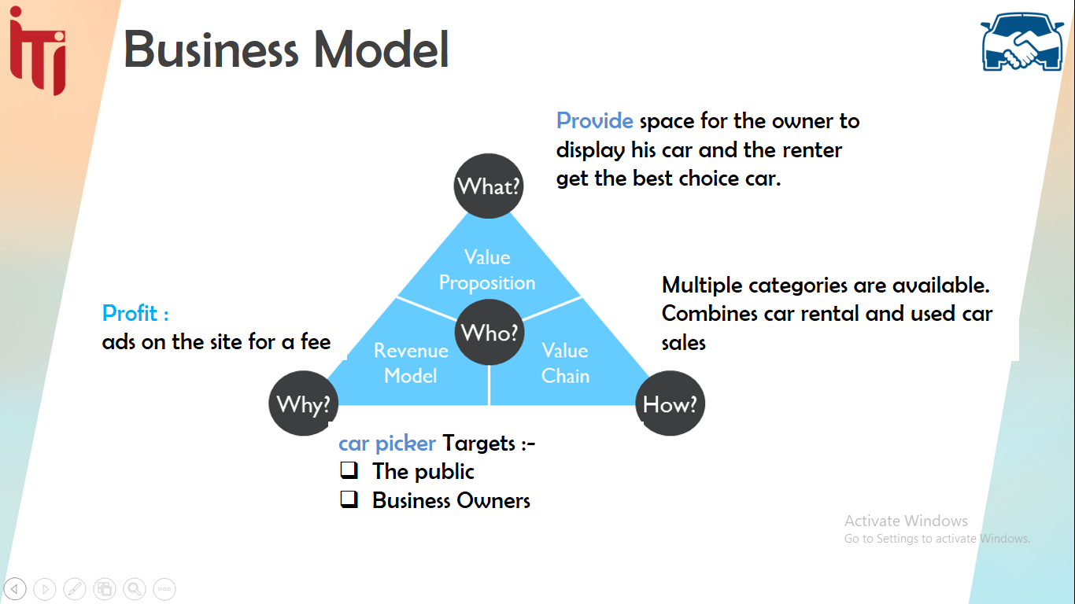

Chapter 2

Requirements

# Requirements

## Functional Requirements

#### List of features or functional requirements

Functional Requirements are those that refer to the functionality of the system, i.e., what services the product will provide to the user, for instance:

* + - * **User**
        + Sign up.
        + Complete Profile
        + Search for cars and filter by price, body Style, production year or brand.
        + Buy car.
        + Rent car.
        + Register car for rent
        + Register car for Sell
        + Edit car details
        + Delete car
        + Login
      * **Admin**
        + Login
        + Add cars.
        + Edit cars
        + Accept / Refuse users.

## Use cases

### **Actors**

* User

### Admin

### **List of use cases**

1. Searching cars.

### Register new account.

### Buy/Rent cars.

### Display cars for rent or sell.

### Manage Cars (Add/Remove).

### Add new admin.

|  |  |  |  |
| --- | --- | --- | --- |
| **Name** | **Sell Car** | **Ref** | **SellCar01** |
| **Description:** | **User uses to Sell his car** | | |
| **Actor:** | **User** | | |
| **Assumption:** | **User own Car** | | |
| **Outcome:** | **User Car viewed in sales Section** | | |
| **Actor** | | **System** | |
| 1-User enter his email and password to login | | 2- if credentials is valid allow user to enter | |
| 4- User enter sales section to sale his car | | 3- redirect to profile | |
| 5- View User’s cars | |
| Alternative 1  after step 5 | | | |
| **Actor** | | **System** | |
| 7-User enter his cars data | | 6- Redirect user to register his owned cars  8- Save Cars’ data and allow user to select car | |
| 9- View his cars’ data then select a car to sell | |
| Alternative 1  After step 2 | | | |
| **Actor** | | **System** | |
| 4- user enter his credentials again | | 3- credentials is not valid so redirect user to login with error message | |

|  |  |  |  |
| --- | --- | --- | --- |
| **Name** | Buy Car | **Ref** | BuyCar01 |
| **Description:** | User want to buy car | | |
| **Actor:** | User | | |
| **Assumption:** | User enter app to buy a car | | |
| **Outcome:** | User view the sold cars | | |
| Actor | | System | |
| 1- User enter his email and password to login | | 2- if credentials is valid allow user to enter | |
| 4- User enter Buy section to buy a car | | 3- redirect to profile | |
| 5-View sold cars | |
| Alternative 1  after step 2 | | | |
| Actor | | System | |
| 4- user enter his credentials again | | 3- credentials is not valid so redirect user to login with error message | |
|  | |
| Alternative 1  After step  5 | | | |
| Actor | | System | |
| 6- user didn’t find his dream car | | 7- View message “Not Found” | |

|  |  |  |  |
| --- | --- | --- | --- |
| **Name** | Search | Ref | Search01 |
| **Description:** | User want to search or compare between cars | | |
| **Actor:** | User | | |
| **Assumption:** |  | | |
| **Outcome:** | User knew the difference between cars | | |
| Actor | | System | |
| 1-user types a car model with desired series | | 2- View Car Details | |
| 3- User Add another car with series next to previous one | | 4-View a comparison between the two cars | |
|  | |
| Alternative 1  after step 1 | | | |
| Actor | | System | |
| 3-User enter another car model with series | | 2-Car not found so return the user a message “Not Found” | |
|  | |

### **2.2.3. Use case diagram:**

### 

Figure 2.1

* 1. **Classes**
     1. List of Classes
* **Car picker Application**
* Users
* User Phones
* Details Category
* Car Details
* User Cars
* Selling Data
* Type
* Model
* Model Class
* Class
* Brand

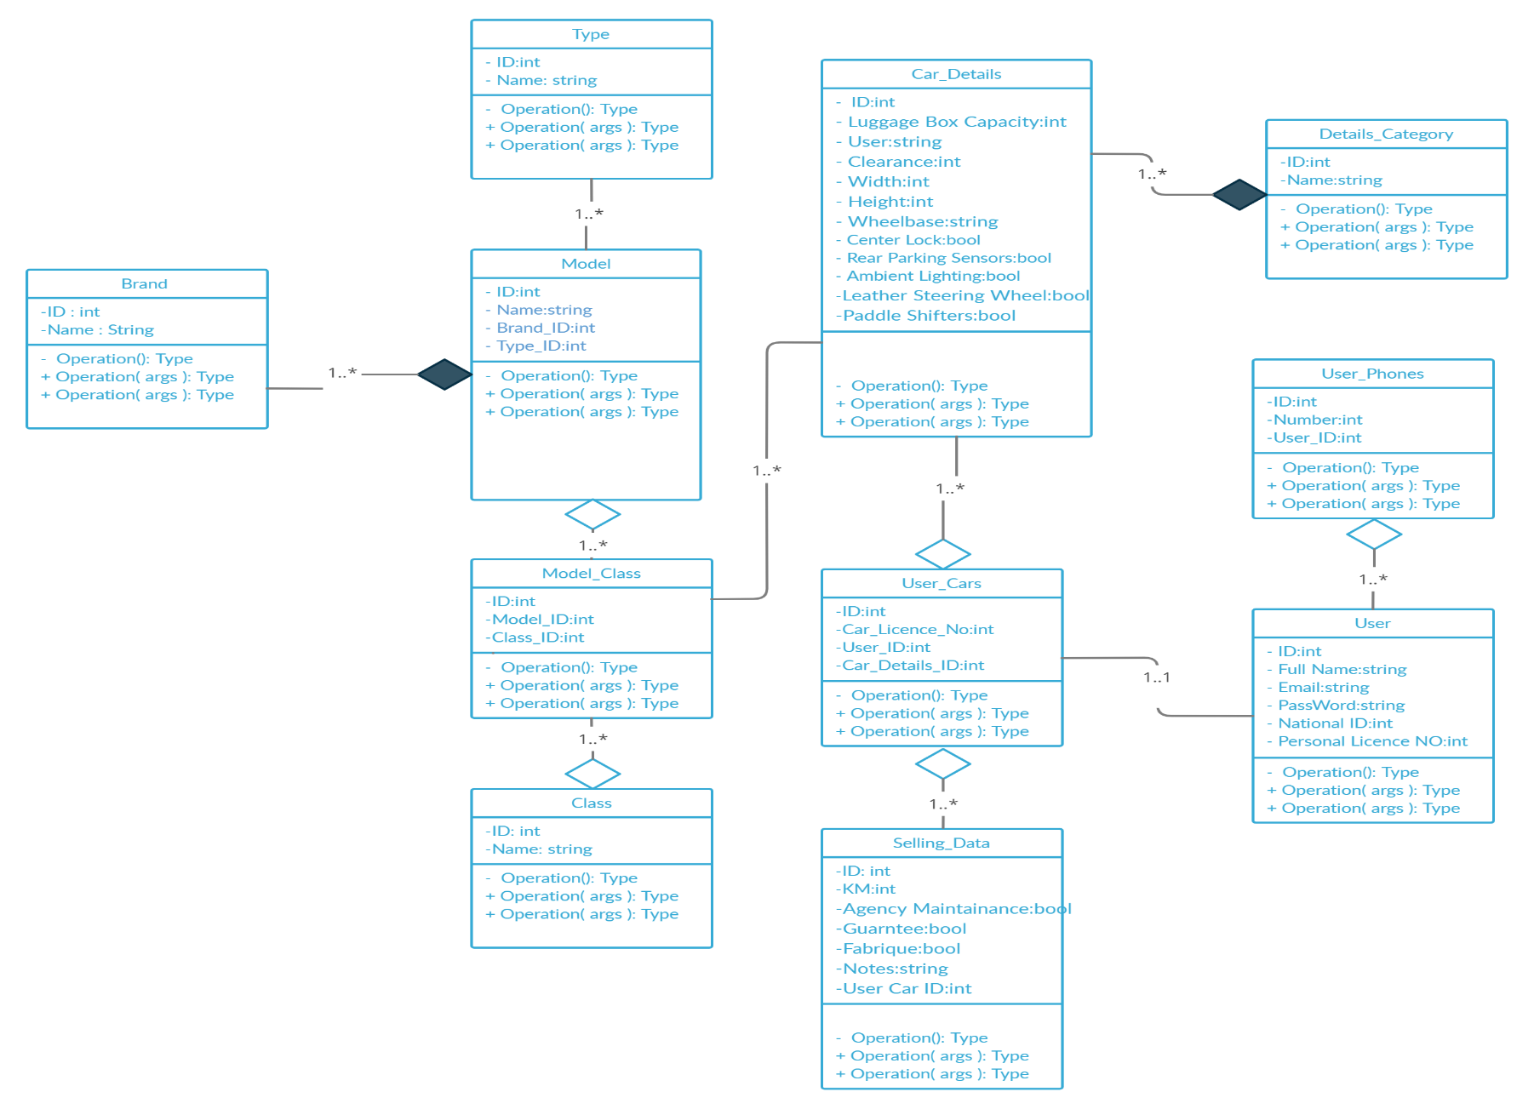

### Non-Functional Requirements

#### Performance Requirements

#### Performance is achieved through clean code and reducing duplicated functions and routes.

#### Accessibility

* + - * All users from all segments can use Car picker website, it supports English version.

#### Cost

#### Car picker is a free and easily accessible website

#### Supportability

* + - * Car picker allows user to feel free to contact with Car picker’s team whenever the user faces any problem and try to solve it with him

#### Quality

* + - * Car picker developed using latest technology in API and Angular.

#### Scalability

* + - * Car picker can handle a growing amount of work by adding resources to the system.

#### Security

* + - * Car picker keeps user’s sensitive information private and secured

#### Stability

* + - * Car picker is a 99% bug free website.

#### Backup

* + - * Car picker can restore lost data easily because it provides a backup for our data in more than one serve

Chapter 3

Objectives

## Objectives (List of Services)

We provide stable and maintainable website that allows users to rent and used cars easily and Search about any car by price, body Style, production year or brand.

* List of services
  + - * **User**
        + Sign up.
        + Complete Profile
        + Search for cars and filter by price, body Style, production year or brand.
        + Buy used car.
        + Rent car.
        + Register car for rent.
        + Register car for Sell.
        + Edit car details.
        + Delete car.
        + Login.
      * **Admin**
        + Login.
        + Add cars.
        + Edit cars (add, remove)
        + Accept / Refuse user

Chapter 4

Design

## Design Overview

* 1. **System Architecture**

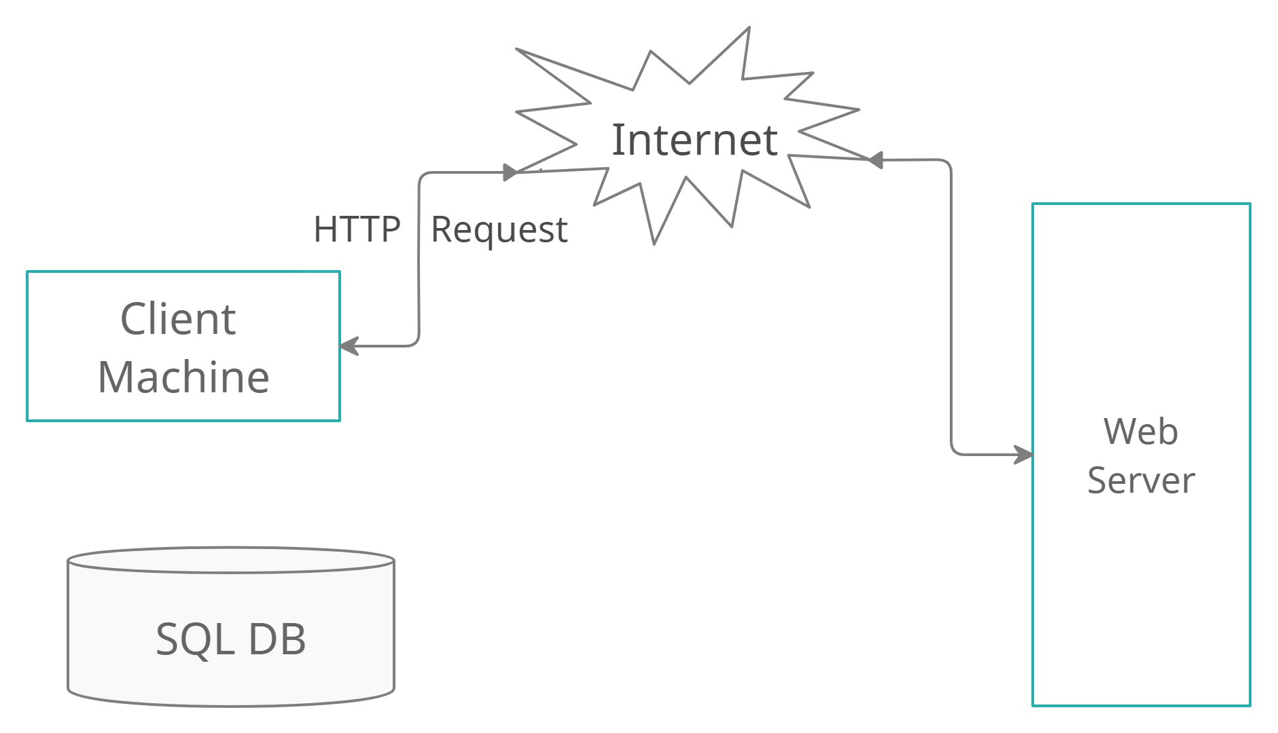

Users Make requests to the web server and receive responses using API and EF.

Database Where data is persisted and retrieved.

**Laboratory**

* 1. **Data Design (Entity Relationship Diagram)**

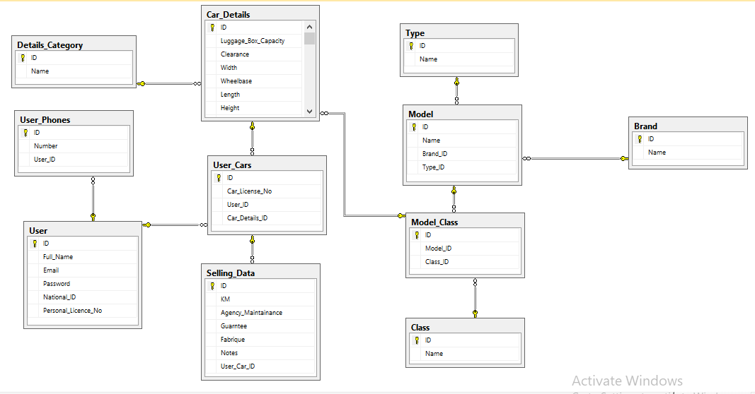

Figure 4.2 ERD diagram

**4.3 SWOT analysis:**

This figure will show our business SWOT analysis:

STRENGTHS

* + **Car picker** provides space for the owner to display his car and the renter get the best choice car.
  + It provides the user with detailed information about the car and ways to communicate with its owner from home.

## WEAKNESSES

* **Car picker** may face some abstracts, and financial difficulty.
* Payments Process not available through our application.
* Technicians have not the ability to rate users.
* The competitor may have larger market share in Egypt.

## OPPORTUNITIES

* Release a mobile application version.
* Add Section for car maintenance centers.
* Finding new markets in Egypt.
* Our users segment is familiar with technology, which will increase the use of our service
* Huge amount of data to be processed
* Risks of willing customers to rent cars online.
* There are no ways to guarantee the rights of the car owner, such as making sure that the renter has a driving license

## THREATS

Chapter 5

Implementation

# Implementation

## Tools and Technologies

|  |  |
| --- | --- |
| **Tools** | **Technologies** |
| 1. Visual studio 2. Visual studio code 3. Postman 4. Ms sql Management studio 5. Creately 6. Ms visio 7. Pycharm 8. Github | 1. Html 2. Html5 3. Css 4. Css3 5. Bootstrap 6. JavaScript 7. Angular 8. Asp. Net core 9. Sql server 10. Python |

## Hardware Requirements

|  |  |
| --- | --- |
| **Laptop** | Most current laptops have high enough specifications to be used to create a website. The most important specification to check on the computer would be the size of the RAM, which should be over 2GB, though more is better. This will ensure that the computer runs quickly and smoothly |
| **Internet** | In order to create a website, access to a high-speed Internet connection can be vital. This allows us to transfer the files that will make up your website to the online server that will be hosting our website, post updates on our website and look at our website live online to make sure that it is displaying correctly. |
| **Server** | We need a server computer to host our website on to make sure  that it is available all the time for anyone trying to access it |

Chapter 6

User/Customer Testing

Chapter 6

Future Work

# Future Work

### Release a mobile application version.

### Add Section for car maintenance centers.

* Payments will be done through our application.

### Technicians have the ability to rate users.

* Taking a percentage from the profit of each sale or rent process.
* More statistics will be provided for other analysis.

Chapter 7

User Guide

# User Guide

# 

# 